# BOOTSTRAP 5

### UTILIDADES- COMPONENTES

Colores barra de navegación Bootstrap: <http://work.smarchal.com/twbscolor/> - Para versión 4

Generador de código Bootstrap: [https://bootsnipp.com/buttons - Hasta version 3](https://bootsnipp.com/buttons%20-%20Hasta%20version%203)

Generador de código Bootstrap 5: [https://generator.ws/demo/#](https://generator.ws/demo/)

Componentes: https://getbootstrap.com/docs/5.0/customize/components/

### Listado de componentes

* [Accordion](https://getbootstrap.com/docs/5.0/components/accordion/)

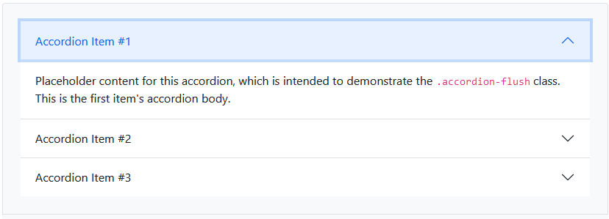

* [Alerts](https://getbootstrap.com/docs/5.0/components/alerts/)

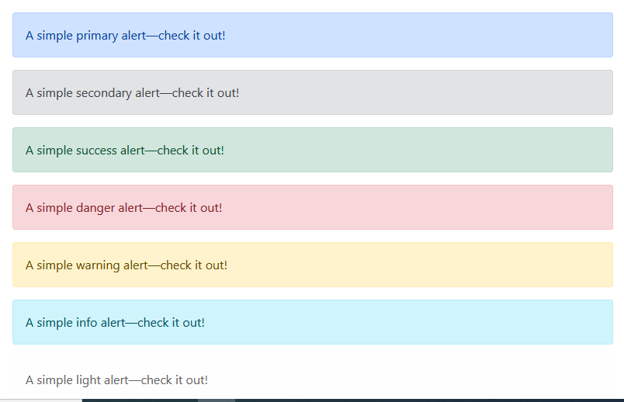

* [Badge](https://getbootstrap.com/docs/5.0/components/badge/)

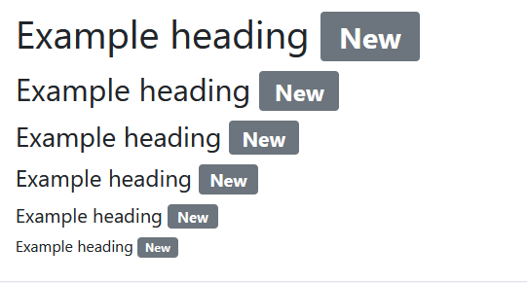

* [Breadcrumb](https://getbootstrap.com/docs/5.0/components/breadcrumb/)

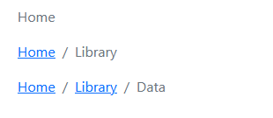

* [Buttons](https://getbootstrap.com/docs/5.0/components/buttons/)

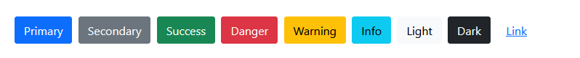

* [Button group](https://getbootstrap.com/docs/5.0/components/button-group/)

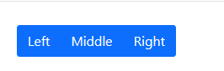

* [Card](https://getbootstrap.com/docs/5.0/components/card/)

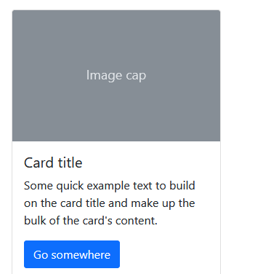

* [Carousel](https://getbootstrap.com/docs/5.0/components/carousel/)

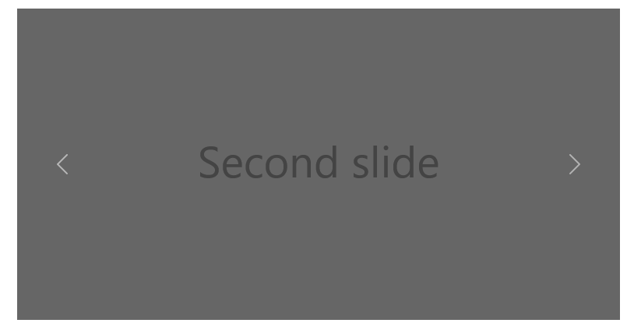

* [Close button](https://getbootstrap.com/docs/5.0/components/close-button/)

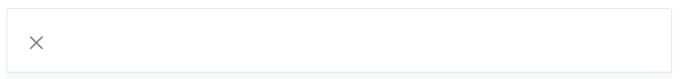

* [Collapse](https://getbootstrap.com/docs/5.0/components/collapse/)

🡪 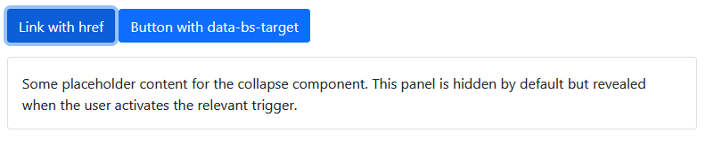

* [Dropdowns](https://getbootstrap.com/docs/5.0/components/dropdowns/)

🡪 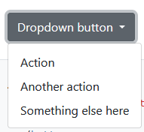

* [List group](https://getbootstrap.com/docs/5.0/components/list-group/)

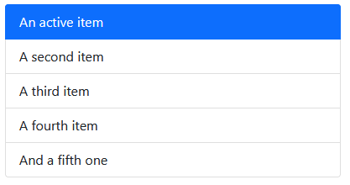

* [Modal](https://getbootstrap.com/docs/5.0/components/modal/)

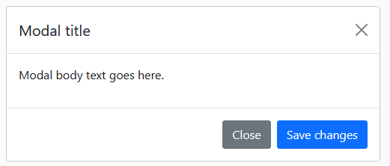

* [Navs & tabs](https://getbootstrap.com/docs/5.0/components/navs-tabs/)

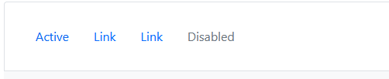

* [Navbar](https://getbootstrap.com/docs/5.0/components/navbar/)



* [Offcanvas](https://getbootstrap.com/docs/5.0/components/offcanvas/)

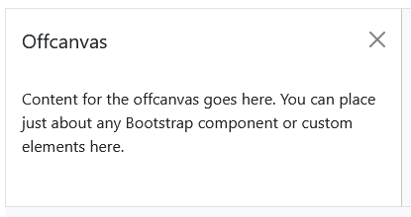

* [Pagination](https://getbootstrap.com/docs/5.0/components/pagination/)



* [Popovers](https://getbootstrap.com/docs/5.0/components/popovers/)

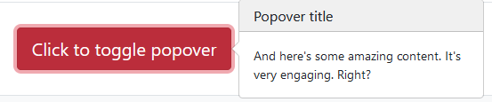

* [Progress](https://getbootstrap.com/docs/5.0/components/progress/)

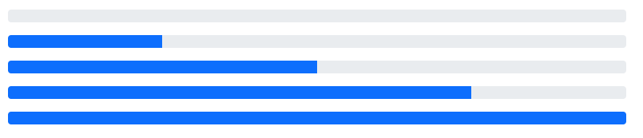

* [Scrollspy](https://getbootstrap.com/docs/5.0/components/scrollspy/)

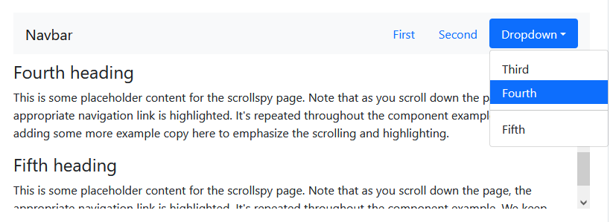

* [Spinners](https://getbootstrap.com/docs/5.0/components/spinners/)



* [Toasts](https://getbootstrap.com/docs/5.0/components/toasts/)

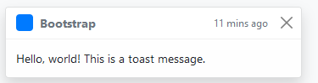

* [Tooltips](https://getbootstrap.com/docs/5.0/components/tooltips/)

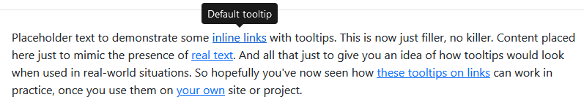

### UTILIDADES

* [Borders](https://getbootstrap.com/docs/5.0/utilities/borders/)
* [Colors](https://getbootstrap.com/docs/5.0/utilities/colors/)
* [Display](https://getbootstrap.com/docs/5.0/utilities/display/)
* [Flex](https://getbootstrap.com/docs/5.0/utilities/flex/)
* [Float](https://getbootstrap.com/docs/5.0/utilities/float/)
* [Interactions](https://getbootstrap.com/docs/5.0/utilities/interactions/)
* [Overflow](https://getbootstrap.com/docs/5.0/utilities/overflow/)
* [Position](https://getbootstrap.com/docs/5.0/utilities/position/)
* [Shadows](https://getbootstrap.com/docs/5.0/utilities/shadows/)
* [Sizing](https://getbootstrap.com/docs/5.0/utilities/sizing/)
* [Spacing](https://getbootstrap.com/docs/5.0/utilities/spacing/)
* [Text](https://getbootstrap.com/docs/5.0/utilities/text/)
* [Vertical align](https://getbootstrap.com/docs/5.0/utilities/vertical-align/)
* [Visibility](https://getbootstrap.com/docs/5.0/utilities/visibility/)

### FORMULARIOS

* [Form control](https://getbootstrap.com/docs/5.0/forms/form-control/)
* [Select](https://getbootstrap.com/docs/5.0/forms/select/)
* [Checks & radios](https://getbootstrap.com/docs/5.0/forms/checks-radios/)
* [Range](https://getbootstrap.com/docs/5.0/forms/range/)
* [Input group](https://getbootstrap.com/docs/5.0/forms/input-group/)
* [Floating labels](https://getbootstrap.com/docs/5.0/forms/floating-labels/)
* [Layout](https://getbootstrap.com/docs/5.0/forms/layout/)
* [Validation](https://getbootstrap.com/docs/5.0/forms/validation/)

### MÁS ELEMENTOS

* [Clearfix](https://getbootstrap.com/docs/5.0/helpers/clearfix/)
* [Colored links](https://getbootstrap.com/docs/5.0/helpers/colored-links/)
* [Ratio](https://getbootstrap.com/docs/5.0/helpers/ratio/)
* [Position](https://getbootstrap.com/docs/5.0/helpers/position/)
* [Visually hidden](https://getbootstrap.com/docs/5.0/helpers/visually-hidden/)
* [Stretched link](https://getbootstrap.com/docs/5.0/helpers/stretched-link/)
* [Text truncation](https://getbootstrap.com/docs/5.0/helpers/text-truncation/)
* [Reboot](https://getbootstrap.com/docs/5.0/content/reboot/)
* [Typography](https://getbootstrap.com/docs/5.0/content/typography/)
* [Images](https://getbootstrap.com/docs/5.0/content/images/)
* [Tables](https://getbootstrap.com/docs/5.0/content/tables/)
* [Figures](https://getbootstrap.com/docs/5.0/content/figures/)
* [Gutters](https://getbootstrap.com/docs/5.0/layout/gutters/)
* [Utilities](https://getbootstrap.com/docs/5.0/layout/utilities/)
* [Z-index](https://getbootstrap.com/docs/5.0/layout/z-index/)